**Curriculum overview**

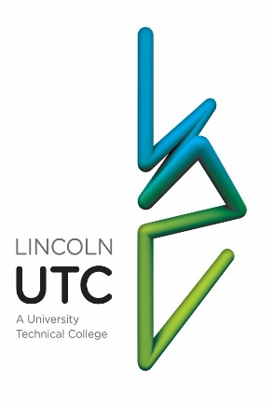

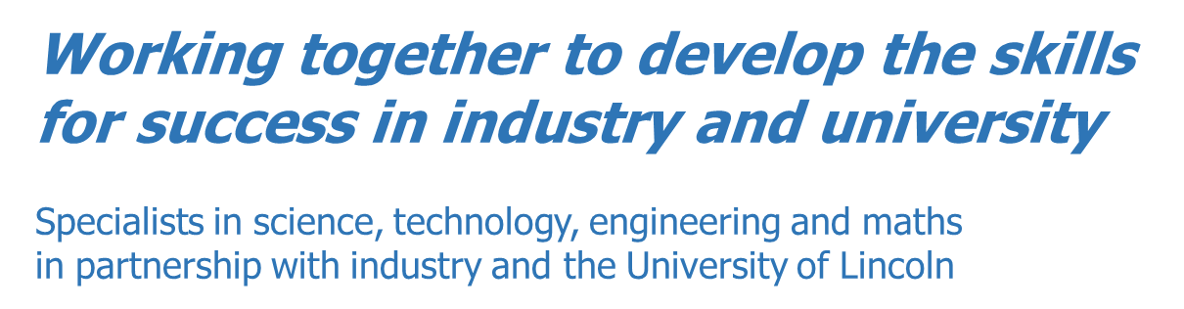

Lincoln UTC is non-selective and committed to being fully inclusive, offering the very best technical education to all … regardless of prior attainment, disadvantage, or special educational need.

Our vision is to ensure that every student develops the skills required to secure the next step of their chosen career, either at university or in employment.

Our curriculum is designed to provide students with both breadth and depth of knowledge and understanding in the subjects that are required for the best careers in science, technology, engineering, and maths (STEM).

All Lincoln UTC students will take GCSEs in English language, English literature and maths, All will take the three separate science GCSEs in biology, chemistry and physics. All will study two engineering disciplines as part of their core curriculum… engineering design and engineering manufacture (OCR National). Students then have one, additional, free option choice.

|  |  |  |
| --- | --- | --- |
| ***Core curriculum*** | | ***Options*** |
| English language | Engineering design | Engineering systems and control |
| English literature | Engineering manufacture | Product design |
| Maths | Biology | Computing |
| Project work | Chemistry | Art |
| Life guidance | Physics | Business (BTEC) |

Our curriculum is spiral in nature. The teaching is designed to ensure that all students are secure in the basics within each topic through repetition and practice which promotes recall, fluency and automaticity… checking that key subject knowledge is transferred to long-term memory. Topics are re-visited regularly and frequently, with work that helps students understand the links between topics, between different subjects and with real world, employment related contexts.

We place an explicit focus on skill development and the acquisition of the traits of the ideal student (detailed below). It pervades all that we do and the ways in which students are encouraged to learn.

We value academic knowledge and technical skills in equal importance to personal qualities. Whilst outstanding qualifications may open a doorway to an interview, the qualities and uniqueness of the individual will clinch the job opportunity.

Students’ learning and personal development is underpinned by our unique ‘Project Curriculum’. Students in year 10 and year 11 have six lessons each week working with their classmates on project challenges (17% of total curriculum time). The shortest of the projects will take two and a half hours (a triple lesson). Most will require the students to work on the same challenge for four consecutive project sessions, spending a total of ten hours grappling with the same problem. Students are not spoon-fed and are not told how to approach or solve the problems that they encounter. There is an expectation, in most of the projects, that the students will make mistakes and fail…that they will then reflect on and learn from these mistakes and become more resilient as a consequence.

Projects are carefully chosen and planned to encourage independent learning (independent of the teacher) and collaborative learning. Many of the projects involve students working in teams. Most of them involve an element of creativity and creative thinking. Students are expected to plan and organise their own approaches to their work. Project challenges support the students’ academic curriculum providing them with opportunities to apply their learning from other subjects and put it into practice.

The weekly ‘life guidance lessons’ contribute to the personal, social, moral, spiritual, and cultural development of our students. This programme promotes the fundamental British values of law, democracy, tolerance and freedom of speech. It is a key part of their relationship and sex education and of the students’ careers education. Students are encouraged to engage with and debate the views, beliefs and opinions of others (that may be different from their own) in considered and respectful ways.

Our entire curriculum is designed to support students’ personal growth and their ability to engage with challenging moral and ethical issues. This is not something that is only covered in life guidance lessons. The study of science and engineering gives our students an understanding of the world’s big issues relating to sustainability, climate, and the environment (and an appreciation of our individual responsibilities). In English lessons, both the fiction and the non-fiction reading that students do is carefully considered and chosen to expose them to others’ perspectives. In project challenges where students practise debating and presentation skills, they are encouraged to explore topics including online safety, politics and how best we should address discrimination and socio-economic injustice.

**The ideal student**

* Ideal students are curious. They want to make sense of the world around them. They have the capacity for awe, wonder and amazement. They want to understand everything.
* They know what is important to them and ‘what makes them tick’. They arrive at all lessons motivated and committed. They are active participants in lessons. They do not rely on others (teachers) to provide their motivation.
* They have high levels of personal organisation. They plan carefully and make good use of their time, hitting all deadlines.
* They are independent and do not regard themselves as hollow vessels waiting to be filled with the information necessary to pass their exams. They do not wait to be spoon fed. They want to find things out for themselves.
* They work well with others, listen to others and appreciate that they can learn most effectively when learning is a collaborative activity. They treat others with respect at all times.
* They are analytical in their thinking ... able to construct a convincing argument for their views and opinions. They always explain their thinking and justify their reasoning.
* They always try to connect their learning to work done before and work that they know is coming. They try to link all new learning … to real life contexts, to their own life experience and to academic work in other subjects.
* They are creative thinkers who are willing to ‘think outside the box’. They are happy to take risks and try new things.
* They set ambitious targets for themselves and are willing to do whatever it takes to realise these goals. They routinely review their progress towards these targets. They ask for feedback as part of this process.
* They aren’t afraid to get things wrong. They are resilient … always ready to ‘get back on the horse’ and try again. They learn from their mistakes, correct all their work and respond positively to constructive criticism. They persevere when things are tough and don’t give up quickly or easily.